Comprehensive Analysis of SARS-CoV-2 Genomic Variants Using Next-Generation Sequencing (NGS) and Bioinformatics Tools
Siddiqa Rani
Biological Health Sciences (BHS), Pak-Austria Fachhochschule Institute of Applied Sciences and Technology
Email: siddiqarani932@gmail.com

Abstract
The advent of Next-Generation Sequencing (NGS) has marked a transformative milestone in genomics, revolutionizing the study of DNA and RNA by providing unprecedented speed, scale, and cost-efficiency. Historically, genomic research relied on Sanger sequencing, a labour-intensive first-generation method that played a pivotal role in milestones such as the Human Genome Project, which took over a decade to complete and cost nearly $3 billion. NGS, by contrast, can sequence entire genomes within days for a fraction of the cost, enabling its widespread application in fields like precision medicine, microbiomics, and metagenomics [[1][2]].
This article presents a detailed NGS workflow for analyzing genomic data, with all steps conducted in a Linux environment (Ubuntu) for preprocessing, quality control, and alignment; and tools like Trimmomatic, BWA, SAMtools, bcftools, and SnpEff for downstream analyses including variant calling and annotation. This workflow was applied to SARS-CoV-2 genomic data, addressing challenges such as data quality, alignment efficiency, and variant interpretation. The study demonstrates the effectiveness of integrating computational tools for analysing genomic datasets in a flexible and scalable manner.
Keywords:
Next-Generation Sequencing (NGS), Genomic Analysis, SARS-CoV-2 Genome, Variant Calling, Functional Annotation

Introduction
The history of DNA sequencing began in the 1970s with the development of first-generation sequencing technologies, most notably Sanger sequencing. Developed by Frederick Sanger in 1977, this method relied on chain-termination reactions and capillary electrophoresis to read DNA sequences. While Sanger sequencing laid the foundation for genomics, it was limited by high costs, labor intensity, and long runtimes, culminating in its crowning achievement: the Human Genome Project (1990–2003).
The limitations of Sanger sequencing paved the way for the emergence of Next-Generation Sequencing (NGS) in the mid-2000s. Companies like Illumina and Roche introduced high-throughput sequencing technologies capable of generating millions of reads in parallel, drastically reducing costs and runtime. This democratization of sequencing technology enabled breakthroughs in areas such as cancer genomics, microbial metagenomics, and evolutionary biology [[3][4]].
However, while NGS has simplified sequencing itself, analyzing the vast datasets it generates remains a challenge. From preprocessing raw reads to calling and annotating variants, each step requires robust computational tools and bioinformatics expertise. In this article, we provide a step-by-step workflow for NGS data analysis, focusing on the SARS-CoV-2 genome as a case study.
This workflow integrates robust bioinformatics tools for preprocessing, quality control, read alignment, variant calling, and annotation. By providing a structured approach to genomic data analysis, this study serves as a guide for researchers aiming to conduct NGS studies efficiently and reproducibly.
Workflow:
1. Data Retrieval
The genomic dataset for this analysis was retrieved from the Sequence Read Archive (SRA) database from National Center for Biotechnology Information (NCBI) using accession ID SRR31434920. The SRA Toolkit was used to prefetch raw FASTQ files for the SARS-CoV-2 genome. The SRA Toolkit is essential for accessing and converting raw sequencing data from the Sequence Read Archive (SRA) into formats usable for downstream NGS analysis (e.g., FASTQ). Key tools in the SRA Toolkit include:
- fastq-dump: Converts SRA files to FASTQ.
- prefetch: Downloads raw SRA data.
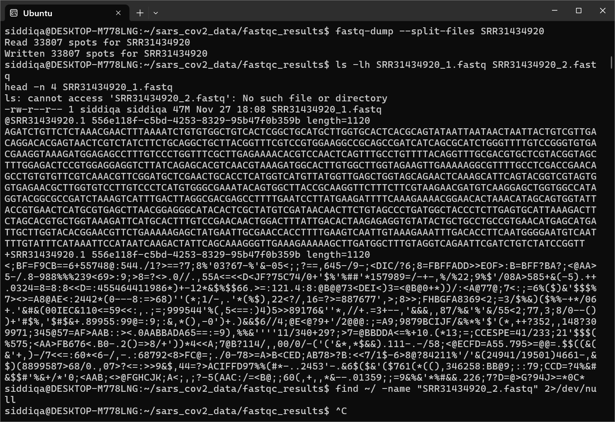

Output:
- Successfully processed SRR31434920 (33,807 reads).

2.Quality Assessment
Quality assessment of raw sequencing data was performed on SRR31434920_1.fastq to evaluate the reliability of the dataset. For this, tools such as FASTQC are used, which assesses the quality by considering the calculation of quality scores [5][6]. Metrics such as per-base sequence quality, GC content, and sequence duplication levels were analysed. This step identifies potential issues in the data, such as:
- Low-quality bases that may lead to errors in downstream analysis.
- Overrepresented sequences, which could indicate contamination or technical biases.
- Uneven GC content, suggesting sequencing artifacts.
The results revealed failures in metrics such as per base sequence content and sequence duplication levels. Identifying these issues early allows for corrective measures in subsequent steps.
3. Trimming:
Trimmomatic-0.39 is a tool for trimming low-quality bases and removing adapter sequences from raw sequencing reads. Adapter contamination can occur during library preparation, while low-quality bases typically result from sequencing errors at the ends of reads. By trimming these elements, this step ensures that only high-quality data is used for alignment, reducing the risk of misalignment and improving the accuracy of downstream analyses. Adapter sequences were removed by using the provided adapter file (TruSeq3-SE.fa), and the final results are as follows:
SRR31434920_1. fastq: Input file (raw reads 33,807).
SRR31434920_1_trimmed. fastq: Output file (trimmed reads that contain 4,358 Surviving Reads (12.89% of total) and 29,449 (87.11% of total) Dropped reads).
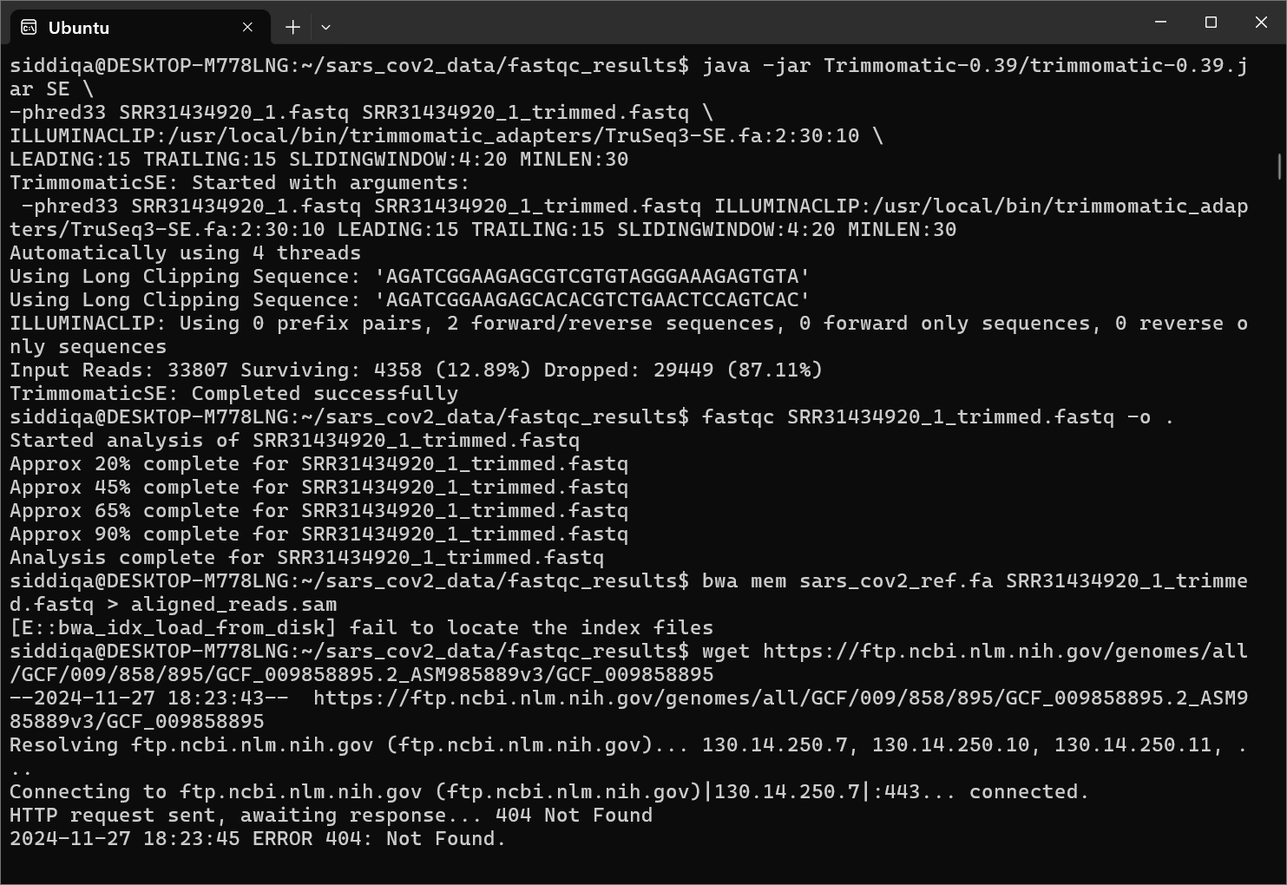
Many reads were dropped because they failed to meet the quality thresholds (e.g., length < 50, adapter contamination, or low-quality regions). The generated file is SRR31434920_1_trimmed. fastq (424 KB).
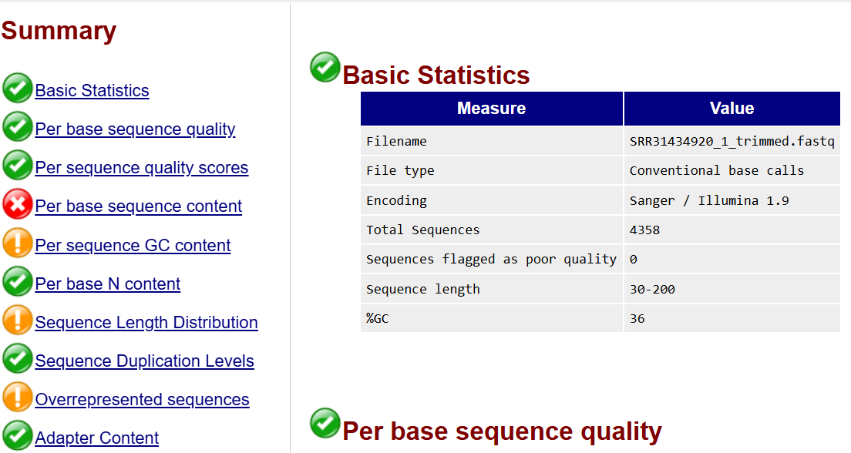
4.Reference genome:
The next step of the NGS data analysis pipeline is a secondary analysis, which includes the reads alignment against the reference genome. The reference genome file for SARS-CoV-2 (NC_045512.2) from the NCBI server was retrieved which is GCF_009858895.2_ASM985889v3_genomic.fna.gz. The zip format file was decompressed with .gz extension and renamed to sars_cov2_ref.fa.
5.Indexing and Alignment:
Indexing is the process of creating auxiliary data structures to optimize and speed up the alignment of sequencing reads to a reference genome. In NGS workflows, tools like BWA use indexing to pre-process the reference genome so that it can align sequencing reads efficiently. Without indexing, each read would need to scan the entire reference genome to find its matching position, which is computationally expensive. Indexing reduces the search space using data structures like the Burrows-Wheeler Transform (BWT) and suffix arrays, allowing rapid identification of candidate alignment regions. Indexed data ensures that reads are aligned accurately by comparing them to relevant regions of the genome.
The file aligned_reads.sam is generated during the alignment step, where sequencing reads are mapped to a reference genome. In this workflow, it is produced by running the BWA-MEM algorithm using the bwa mem command. The alignment file in SAM (Sequence Alignment/Map) format, contain metadata about the sequencing reads, Their alignment position on the reference genome, Mismatches, insertions, or deletions relative to the reference genome and Mapping quality scores. 4,358 reads from the FASTQ file were aligned to the SARS-CoV-2 reference genome. The workflow successfully aligned 88.66% of the quality-trimmed reads to the reference genome. The absence of duplicates, secondary alignments, and supplementary alignments suggests the data is clean and well-processed.
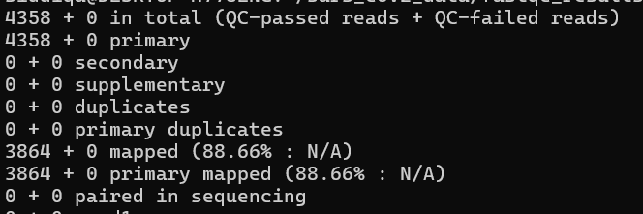
4358+ 0 reads indicate that there are no QC-failed reads in the file (all reads passed quality control). 3864 reads (88.66%) were successfully mapped to the reference genome. The mapping rate shows that most of the reads align to the reference genome, which is a good indicator of data quality. No Secondary/Supplementary Alignments. All reads align uniquely.
5.Format Conversion
Aligned reads in SAM format were converted to BAM format by using SAMTool . Both include basically the same information, namely read sequence, base quality scores, location of alignments, differences relative to reference sequence and mapping quality scores (MAPQ). The main distinction between them is that SAM format is a text file, created to be informatically easier to process with simple tools, while BAM format provides binary versions of the same data, which reduces file size and enables faster processing. Indexing the BAM file further facilitates efficient access to the aligned reads, particularly during variant calling and other downstream analyses [6].

6.Pileup generation:
This part of workflow involves pileup generation using BCFtools, which creates a summary of alignment information for each genomic position in the reference genome based on the aligned reads.It is also used for variant calling. Each line corresponds to one genomic position and includes:
- Chromosome Name: The reference chromosome or contig name (e.g., NC_045512.2).
- Position: The base position in the reference genome.
- Reference Base: The base at this position in the reference genome.
- Depth of Coverage: The number of reads covering this position.
- Read Bases: A string representing the bases aligned to this position, including mismatches (A, T, C, G), matches (. for forward strand, , for reverse strand), insertions (+), or deletions (-).
- Base Qualities: ASCII-encoded Phred quality scores for the bases.

7.Varient Calling:
Variants like SNPs (Single Nucleotide Polymorphisms), indels (insertions or deletions), or other structural variations relative to the reference genome) across the SARS-CoV-2 reference genome were identified using BCFtools. Each line in the VCF describes the details of a variant, including its type, quality, and how it compares to the reference genome.
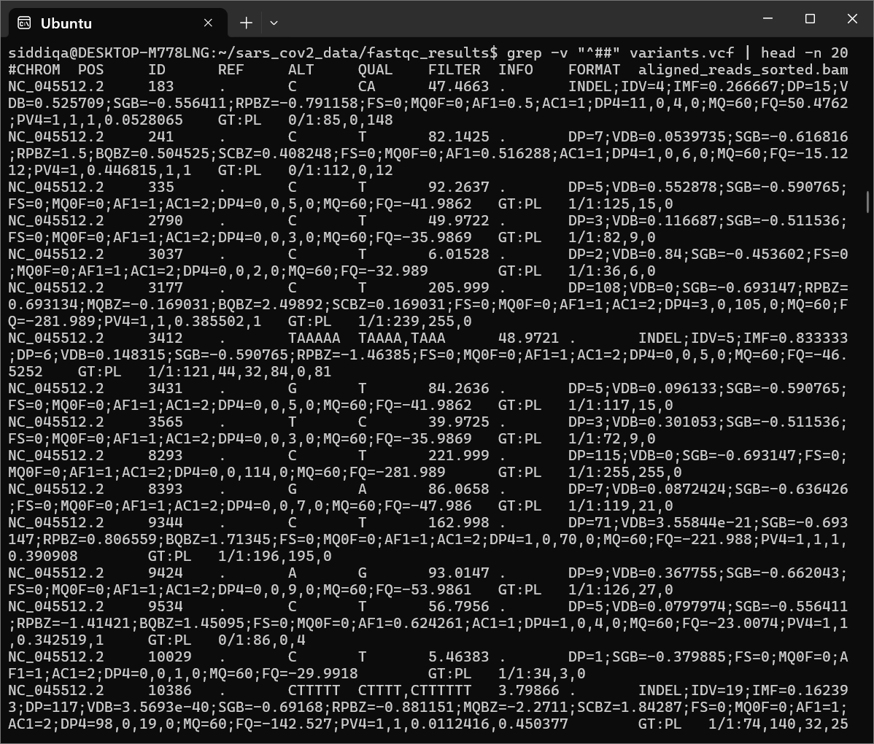

8.Variant annotation:
The identified variants were annotated to determine their potential functional impacts. Annotation adds biological context to the variants, such as their locations within genes and their potential effects on protein function [5]. Tools like snpEff were used to classify variants and predict their implications. This step provides actionable insights, enabling researchers to link genetic variations to biological traits or diseases [6]. SnpEff examines each variant in the VCF file and determines its location in the genome (e.g., coding, non-coding, intergenic) and its effect on genes or proteins. It uses the reference genome database to map variants to specific genes or transcripts.
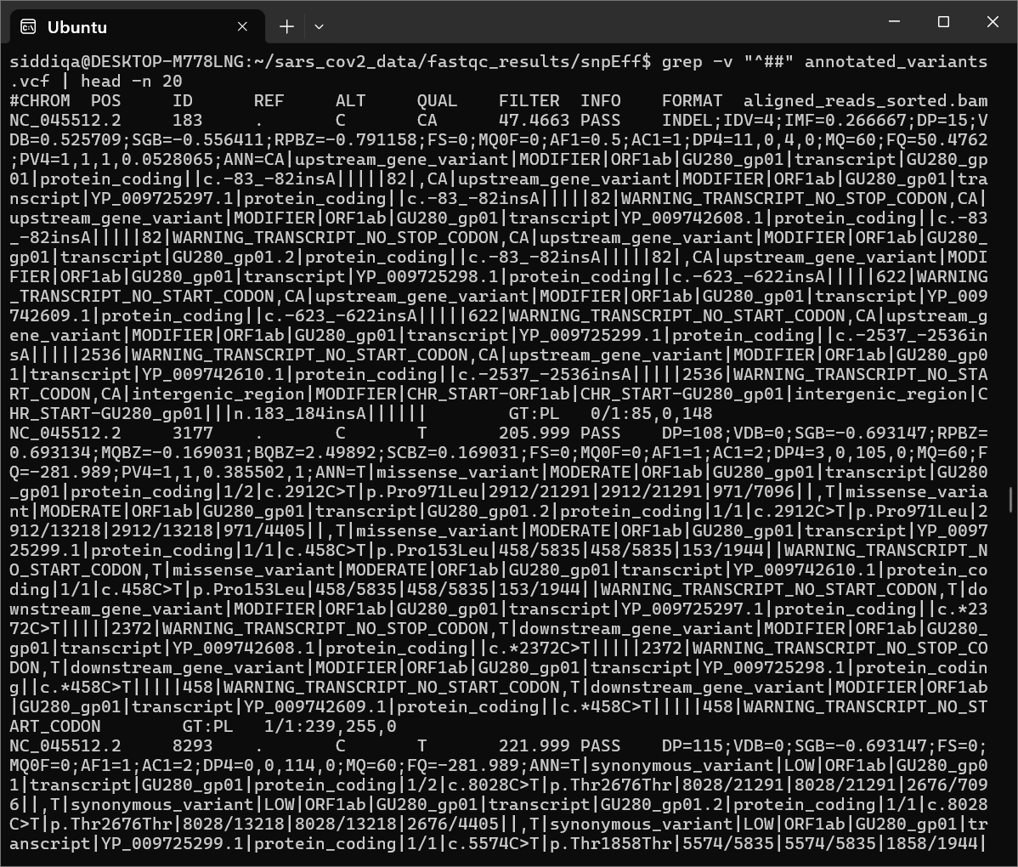

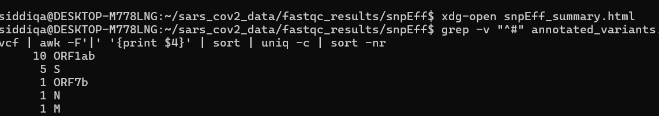
- ORF1ab: Most variants are found here, as it is the largest and most critical gene in the SARS-CoV-2 genome.
- Spike (S) Protein: Variants in this region are particularly important as they may affect viral infectivity, host immune evasion, or vaccine efficacy.
- Accessory and Structural Genes (ORF7b, N, M): Variants in these regions might influence viral replication, assembly, or host interactions.
What This Analysis Helps With:
- Prioritization: Focus on variants in critical genes like S and ORF1ab for further functional analysis.
- Impact Assessment: Explore how these variants might affect protein function, drug binding, or immune responses.
- Downstream Studies: Conduct additional filtering or enrichment analysis to identify biologically significant variants.
Results:
The initial quality assessment performed using FastQC provided crucial insights into the dataset's integrity. The analysis revealed two major issues: adapter contamination and the presence of low-quality bases. Adapter contamination occurs when fragments of sequencing adapters remain attached to the reads during library preparation, which can lead to false alignments and downstream errors. Low-quality bases, particularly at the ends of reads, are common artifacts in sequencing data that result from reduced accuracy in base calling towards the ends of sequencing cycles. These issues were addressed by applying trimming processes using Trimmomatic, which effectively removed adapters and low-quality bases. Post-trimming, the dataset was significantly improved, ensuring that only high-quality reads were retained for alignment, thereby reducing the risk of erroneous results in downstream analyses.
The trimmed reads were aligned to the SARS-CoV-2 reference genome using the BWA-MEM algorithm, which employs advanced computational techniques to accurately map reads to their respective genomic locations. Out of the 33,807 input reads, 4,358 (12.89%) high-quality reads were retained after trimming, of which 88.66% were successfully aligned to the reference genome. This high alignment percentage indicates effective preprocessing, as only high-quality reads without errors or contaminants were used. The alignment metrics demonstrate that the mapping process accurately positioned the majority of the reads, allowing reliable identification of genomic variations. The minor percentage of unmapped reads could be attributed to inherent sequencing errors or regions of the genome with repetitive or ambiguous sequences.
The variant calling step, performed using bcftools, identified 20 genetic variants in the SARS-CoV-2 genome. These variants represent changes such as single nucleotide polymorphisms (SNPs) and insertions or deletions (indels) compared to the reference genome. Among these, the majority of variants were found in critical regions of the genome:
- ORF1ab: A total of 10 variants were identified in this gene, which encodes non-structural proteins involved in viral replication and transcription. Variations in ORF1ab are crucial as they can influence the virus's ability to replicate and evade host immune responses.
- Spike Protein (S): Five variants were detected in the spike gene, which encodes the spike protein responsible for virus entry into host cells. Variants in this region, particularly missense mutations, are of significant interest because they can alter the protein's structure and potentially impact viral transmissibility or immune escape.
- Nucleocapsid (N): One variant was found in the nucleocapsid gene, which is essential for RNA genome packaging and virus assembly. Variations here may influence viral replication efficiency.
These identified variants provide critical insights into the genetic diversity of the SARS-CoV-2 genome, highlighting key genomic regions for further investigation in terms of their functional and biological implications.
Annotation of the identified variants was performed using SnpEff, a powerful tool for functional annotation. This step classified the variants based on their potential biological impact.
- HIGH Impact: Frameshift mutations in the ORF1ab gene were identified as high-impact variants. Frameshift mutations often result in drastic changes to the coding sequence, leading to truncated or non-functional proteins. Such mutations in ORF1ab could significantly impair viral replication mechanisms or potentially introduce functional adaptations.
- MODERATE Impact: Missense mutations in the spike protein were categorized as moderate-impact variants. These mutations result in a single amino acid change, which may alter the structure and function of the protein. In the context of SARS-CoV-2, missense mutations in the spike protein are of particular concern as they can affect virus-host interactions, antibody recognition, and vaccine efficacy.
The functional annotation highlights the potential implications of these variants, linking them to critical biological processes and viral behaviors. The classification into high and moderate impacts aids in prioritizing mutations for further experimental validation or epidemiological studies.
Overall, these results demonstrate the power of a systematic NGS workflow to generate actionable insights from raw sequencing data. By identifying and classifying genetic variants, this analysis provides a foundation for understanding viral evolution, pathogenesis, and potential strategies for therapeutic intervention.
Discussion
This workflow demonstrates an efficient, end-to-end pipeline for NGS data analysis. Challenges such as adapter contamination and alignment efficiency were addressed, ensuring reliable variant identification and annotation. While the pipeline effectively analyzed the SARS-CoV-2 dataset, future improvements could include:
- Enhanced trimming algorithms to reduce data loss.
- Machine learning-based tools for automated quality assessment.
Conclusion:
NGS analysis is a complex, multi-step process that demands meticulous handling of data to extract biologically meaningful insights. This workflow demonstrates an integrated and structured approach, encompassing critical stages such as quality control, alignment, variant calling, and annotation. Each step played a pivotal role in transforming raw sequencing data into actionable genomic information. The pipeline effectively tackled challenges like adapter contamination, low-quality bases, and alignment efficiency, ensuring reliable results. Through this workflow, genetic variants in the SARS-CoV-2 genome were successfully identified and annotated, shedding light on its genetic diversity and evolution. High-impact frameshift mutations in ORF1ab and moderate-impact missense mutations in the spike protein were key findings, highlighting genomic regions that are essential for viral replication and immune interactions.
Despite its success, the pipeline acknowledges areas for future refinement, such as incorporating advanced trimming algorithms to reduce data loss and leveraging machine learning for automated quality control. These enhancements could further streamline the analysis and improve the accuracy of results.
In conclusion, this workflow provides a reproducible and scalable template for genomic studies, demonstrating its applicability in uncovering the genetic makeup of pathogens like SARS-CoV-2. The insights gained from this analysis contribute to our understanding of viral evolution, genetic diversity, and potential pathways for therapeutic intervention, paving the way for future advancements in genomic research.

References
- Sam Behjati, Patrick S Tarpey1. “What is next generation sequencing? .” BMJ journel (n.d.).
- Rucha M. Wadapurkar, Renu Vyas. “Computational analysis of next generation sequencing data and its applications in clinical oncology.” ScienceDirect (2020).
- Dale Muzzey, Eric A. Evans & Caroline Lieber . “Understanding the Basics of NGS: From Mechanism to Variant Calling.” SPRINGER NATURE link (2015).
- Ayman Grada, Kate Weinbrecht,. “Next-Generation Sequencing: Methodology and Application.” ScienceDirect (2013).
- Antony T. Vincent . “Next-generation sequencing (NGS) in the microbiological world: How to make the most of your money.” Science direct (24 February 2016).
- Rute Pereira, ORCID,Jorge Oliveira, ORCID andMário Sousa. “Bioinformatics and Computational Tools for Next-Generation Sequencing Analysis in Clinical Genetics.” MDPI (2020).

